import numpy as np

import pandas as pd

data = {

    "Year" : np.arange(2010,2020),

    "Sales_A" : np.random.randint(100,500,10),

    "Sales_B" : np.random.randint(200,600,10),

    "Profit_A" : np.random.randint(50,200,10),

    "Profit_B" : np.random.randint(80,250,10),

    "Region" : np.random.choice(["North","South","East","West"],10)

}

df = pd.DataFrame(data)

print(df)

Year Sales_A Sales_B Profit_A Profit_B Region

0 2010 431 245 142 169 East

1 2011 125 555 108 191 West

2 2012 250 417 62 232 South

3 2013 316 486 148 208 East

4 2014 173 319 129 204 South

5 2015 443 279 148 155 North

6 2016 459 502 188 102 North

7 2017 335 573 88 137 West

8 2018 147 577 73 203 North

9 2019 249 586 119 243 West

import matplotlib.pyplot as plt

plt.figure(figsize=(10,6))

plt.plot(df["Year"],df["Sales_A"],label="Sales A",marker="o")

plt.plot(df["Year"],df["Sales_B"],label="Sales B",marker="s")

plt.xlabel("Year")

plt.ylabel("Sales")

plt.title("Sales Trend over Years")

plt.legend()

plt.grid(True)

plt.show()

plt.figure(figsize=(10,6))

plt.bar(df["Year"],df["Sales_A"],label="Sales A")

plt.xlabel("Year")

plt.ylabel("Sales")

plt.title("Sales Comparsion")

plt.legend()

plt.show()

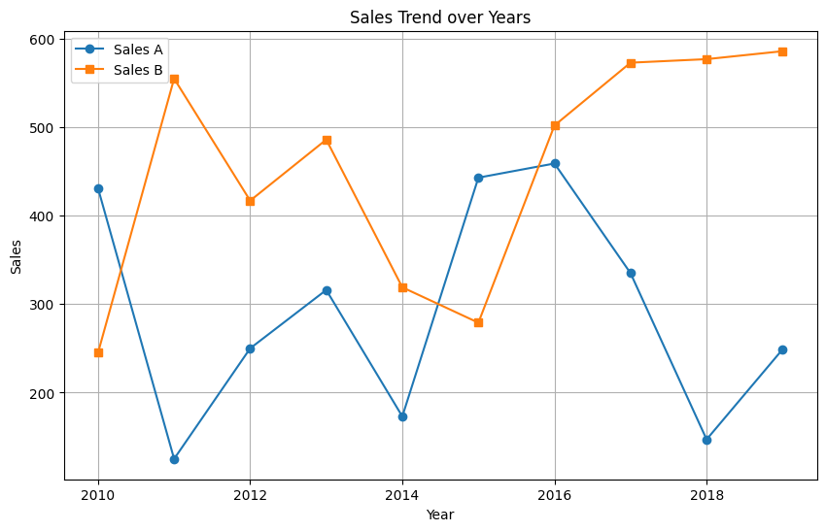plt.figure(figsize=(10,6))

plt.bar(df["Year"],df["Sales_A"],label="Sales A")

plt.xlabel("Year")

plt.ylabel("Sales")

plt.title("Sales Comparsion")

plt.legend()

plt.show()

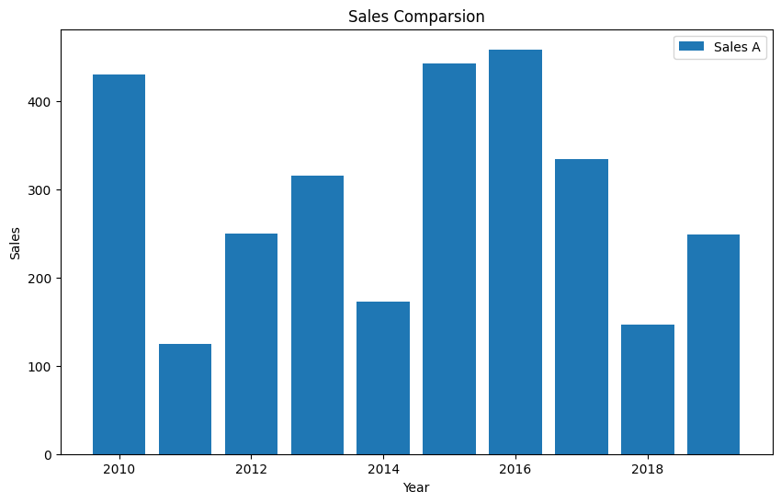# Scatter Plot

plt.figure(figsize=(10, 6))

plt.scatter(df['Sales_A'], df['Profit_A'], label='Sales vs Profit A',

color='blue')

plt.scatter(df['Sales_B'], df['Profit_B'], label='Sales vs Profit B',

color='green')

plt.xlabel('Sales')

plt.ylabel('Profit')

plt.title('Sales vs Profit Scatter Plot')

plt.legend()

plt.grid(True)

plt.show()

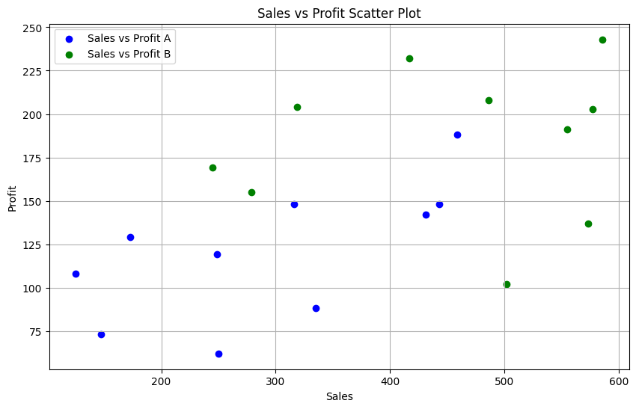# Stacked Bar Chart

plt.figure(figsize=(10, 6))

plt.bar(df['Year'], df['Sales_A'], label='Sales A')

plt.bar(df['Year'], df['Sales_B'], label='Sales B',

bottom=df['Sales_A'])

plt.xlabel('Year')

plt.ylabel('Sales')

plt.title('Stacked Bar Chart of Sales')

plt.legend()

plt.show()

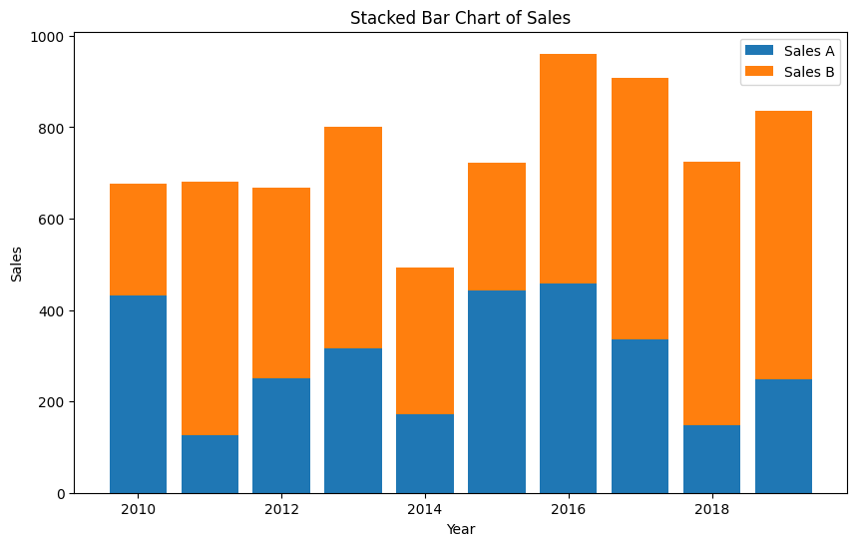# Pie Chart

total_sales = df['Sales_A'].sum() + df['Sales_B'].sum()

sales_a_percentage = df['Sales_A'].sum() / total_sales

sales_b_percentage = df['Sales_B'].sum() / total_sales

labels = ['Sales A', 'Sales B']

sizes = [sales_a_percentage, sales_b_percentage]

colors = ['skyblue', 'lightgreen']

plt.figure(figsize=(4, 4))

plt.pie(sizes, labels=labels, colors=colors, autopct='%1.1f%%',

startangle=90)

plt.title('Sales Distribution')

plt.axis('equal') # Equal aspect ratio ensures that pie is drawn as a circle

plt.show()

# Pie Chart

total_sales = df['Sales_A'].sum() + df['Sales_B'].sum()

sales_a_percentage = df['Sales_A'].sum() / total_sales

sales_b_percentage = df['Sales_B'].sum() / total_sales

labels = ['Sales A', 'Sales B']

sizes = [sales_a_percentage, sales_b_percentage]

colors = ['skyblue', 'lightgreen']

plt.figure(figsize=(4, 4))

plt.pie(sizes, labels=labels, colors=colors, autopct='%1.1f%%',

startangle=90)

plt.title('Sales Distribution')

plt.axis('equal') # Equal aspect ratio ensures that pie is drawn as a circle

plt.show()